 | 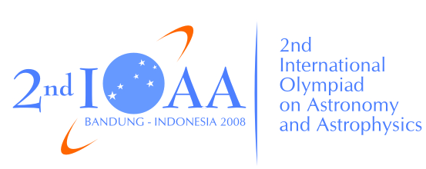 | 

The 2nd International Olympiad on Astronomy and Astrophysics
Bandung, Indonesia

Saturday, 23 August 2008

Theoretical Competition

Please read this carefully:
- Every student receives problem sheets in English and/or in native language,
an answer book and a scratch book.
- The time available is 5 hours for the theoretical competition. There are fifteen short questions (Theoretical Part 1), and three long questions (Theoretical Part 2).
- Use only Black or dark blue pen
- Use only the front side of answer sheets. Write only inside the boxed area.
- Begin answering each question on a separate sheet.
- Numerical results should be written with as many digits as are appropriate.
- Write on the blank answer sheets whatever you consider is required for the solution of each question. Please express your answer primarily in term of equations, numbers, figures, and plots. If necessary provide your answers with concise text. Full credit will be given to correct answer with detailed steps for each question. Underline your final result.
- Fill in the boxes at the top of each sheet of paper with your country code and your student code.
- At the end of the exam place the books inside the envelope and leave everything on your desk.

